Electrical Automation Technology, Control Systems Technology & Electrical Design Systems Technology
Performance Test #1, Switching Circuit

Name: _______________________ Instructor Verification: __________ Grade: __________

Materials:
Materials Provided by You | Materials Provided by the Dept.
1. Necessary Tools | 1. Single Pole Switch
2. 14/2 w/Ground NM-B or MC Cable | 2. Lamp Holder
3. Wire Kit

Objective:
Given the necessary materials, the student will construct an electrical circuit to the specifications listed, as evidenced by scoring a minimum of 75% on this performance test.

Time Limit:
You are allowed 45 minutes to complete the circuit. Five points for every five minutes over the allotted time will be deducted from the score. The maximum overtime allowed is fifteen minutes.

Description of the Circuit:
Construct a circuit in which power is fed to a single pole switch box. The switch controls a light. All devices are installed in metal boxes. This circuit is to be completed within a 45-minute time limit.

Part 1 (+50 points):
Using a straight edge, draw how this circuit will be wired. Five points will be deducted for each error.
Start Time: __________ Finish Time: __________

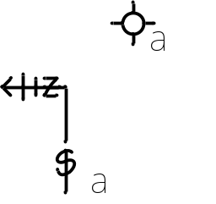



Performance Test # 1

Part # 2 (+ 50 points):
Construct the circuit.

__________ Circuit wired correctly. +5 points

__________ 6” of free conductor from the edge of the box. +5 points

__________ Wire nut connections secure. +5 points

__________ Conductors on device correctly. +5 points

__________ 1/4” cable sheath inside box. +10 points (if NM-B is used)

__________ All anti-short bushings in place. +10 points (if MC is used)

__________ Circuit works as described. +20 points (Troubleshooting yourself +10)

